Performing a general data analysis

**Importing libraries:**

1. First of all I imported all the libraries into the jupyter notebook to perform analysis.

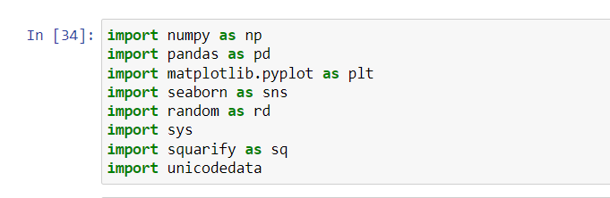

1. second step by using pandas library I read the csv into data frame

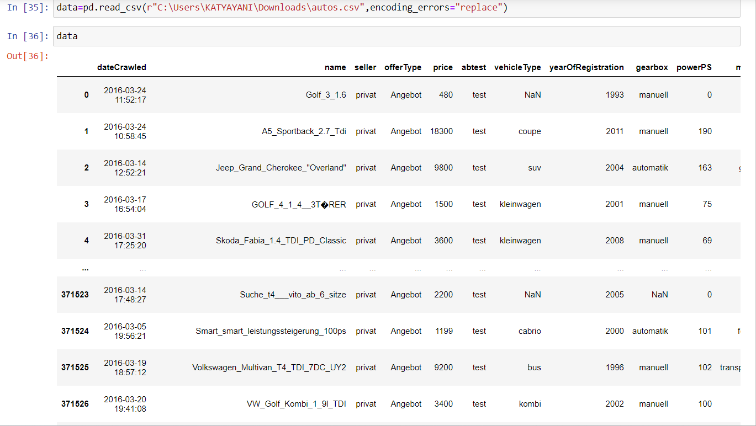

3.by converting csv file into data frame I can see perfectly how many columns is present in data set.

4.by knowing how many colums and rows presented in data we can perform analysis easily.

5.by seeing the below picture we can known that how many rows and columns present in data set.

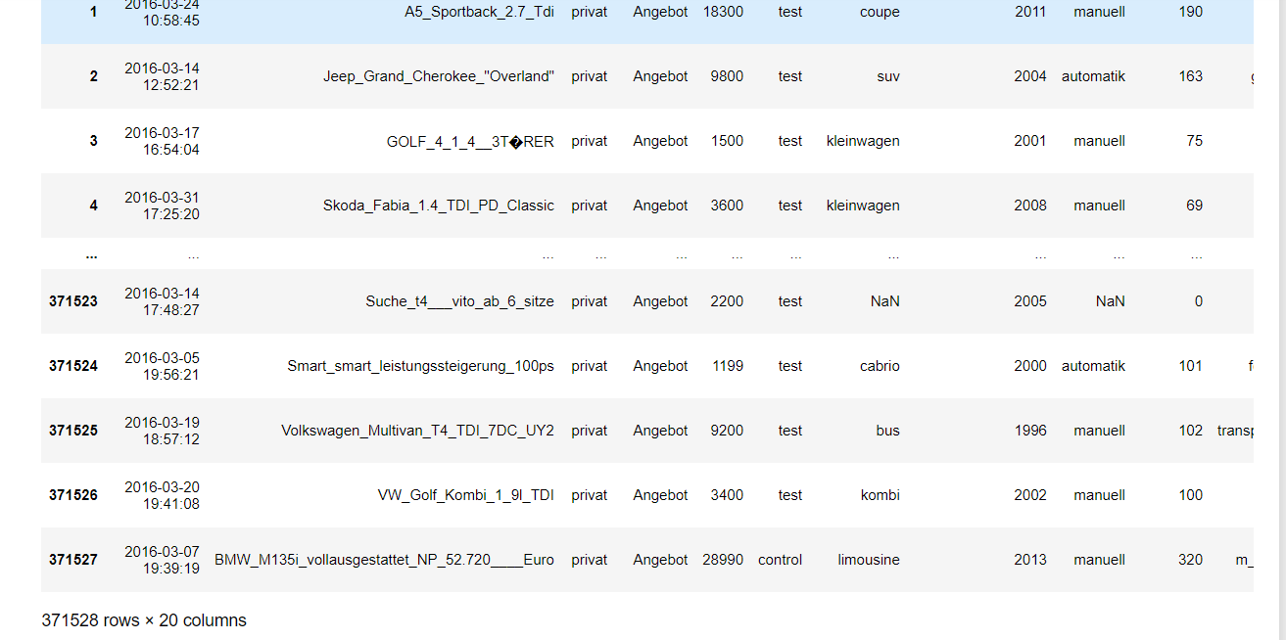

1. By seeing the data set I founded that The data set has 371528 data points. This data set is about the different vehicles available for sale.the data set has total 20 columns in that 7 are int64 data type and remaining 13 has object type.It takes total 56.7+ mb memory space.

**#1.The memory usage of the data is around 6.1 mb. How can we reduce the memory usage of the data set?**

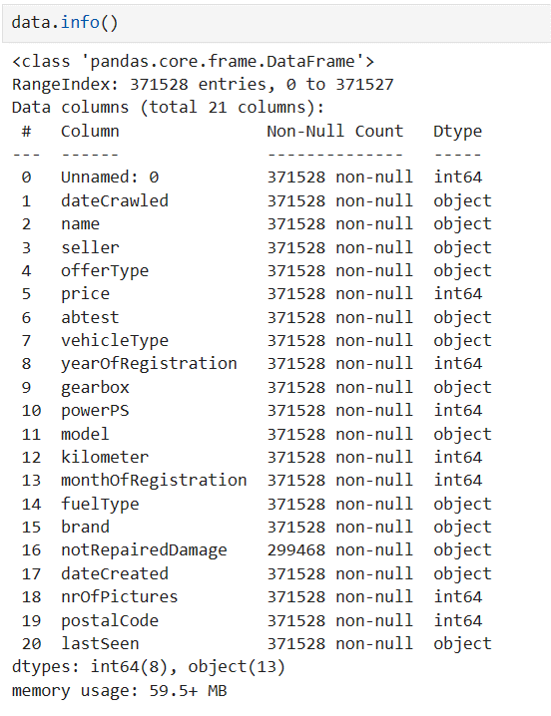

* The memory usage of the data set is as you can see 59.5+ MB.
* By using the below code I dropped some columns which are not use full and I changed the data type of some columns.
* After dropping those columns and changing the data types of some columns the memory usage of the data set is decreased to 41.8+MB.

**2.what is the average price of vehicle by fuel type and gearbox type And give a plot.**

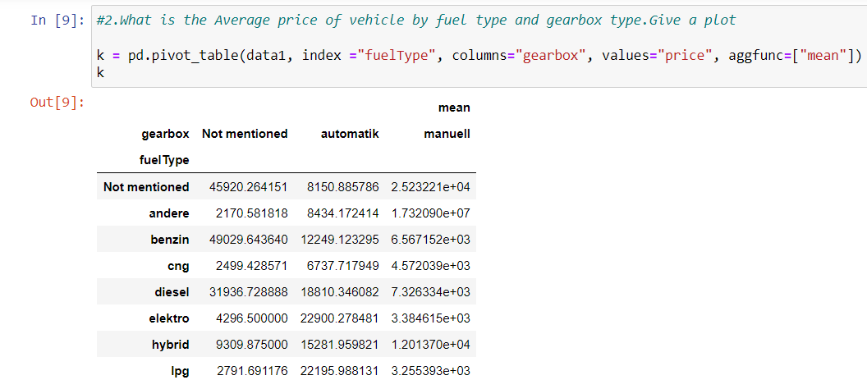

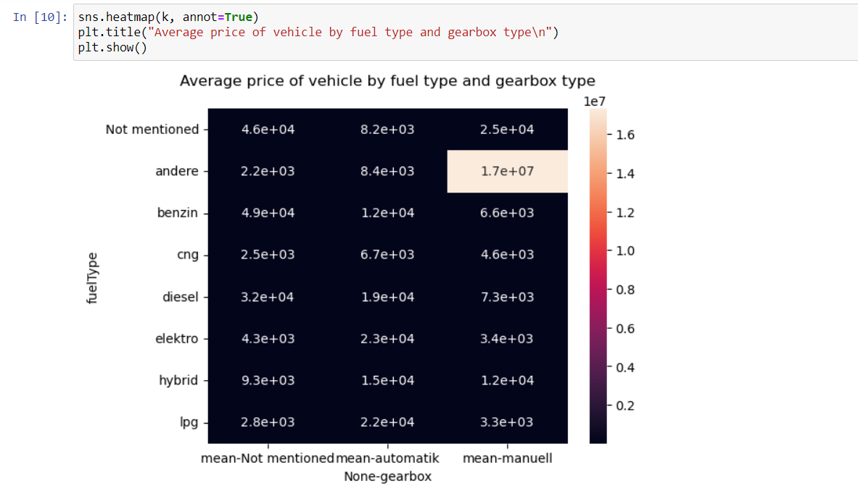

From the above plot I can tell that andere fuel type in manuell gearbox type has more average price when compared to all others.

**3.What is the Average power of a vehicle by vehicle type and gearbox type Give a plot.**

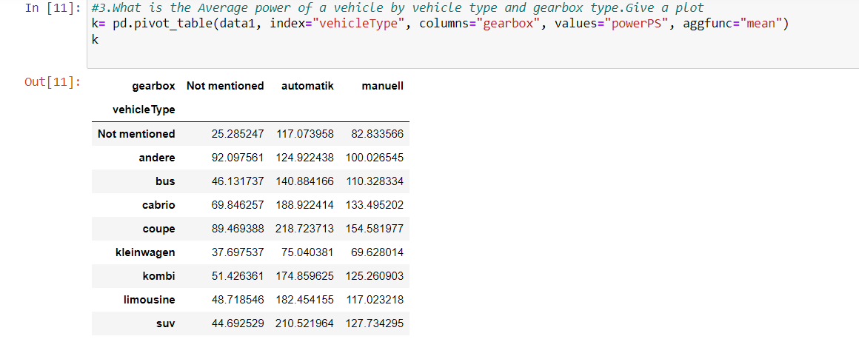

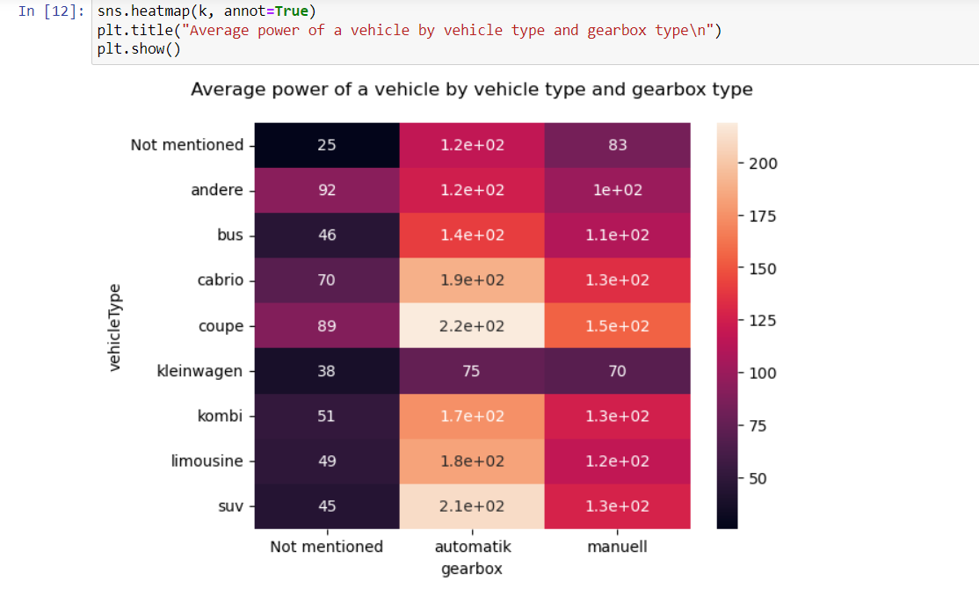

From the above plot we can see that coupe vehicle type has more average price when compared to other vehicle types. And in that coupe vehicle type automatic gear box type has more average price than other two gear box types.

**4.What is the Average price of a vehicle by brand as well as vehicle type.Use heatmap to explain this.**

